Map 2. Inequality between White Other and White British within districts of England and Wales, 2011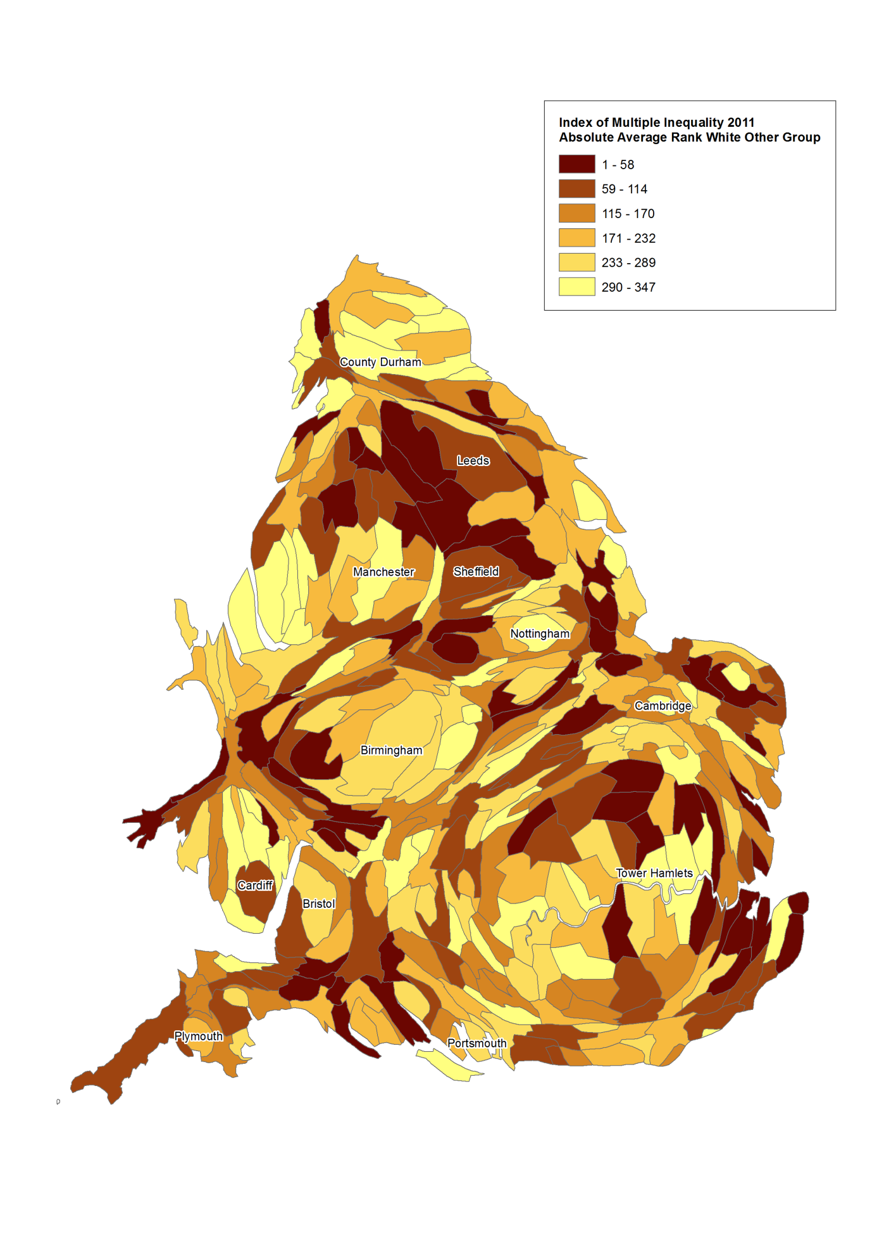
Note: The Index of Multiple Inequality is a rank of districts in England and Wales based on the average of the rankings of each district across the indicators of absolute inequality. Districts scoring on less than two indicators are excluded.

